Habitats Directive Project Screening Assessment

Table 1: Project Details

Development Consent Type | Part 8
Development Location | Bogmeadow Car park, Townland of Monastery, Enniskerry, Co. Wicklow
File Ref

Description of the project | Upgrade of existing car park to include a bus turn around and bus terminus and all associated works (footpaths, kerbing, surfacing, lighting etc.) and construction of a raised speed table with a courtesy pedestrian crossing on Monastery Road.

Table 2: Identification of Natura 2000 Sites (SACs and SPAs) which may be impacted by the Proposed Development

Please answer the following five questions in order to determine whether there are any Natura 2000 sites which could potentially be impacted by the proposed development.

Impacts on SACs
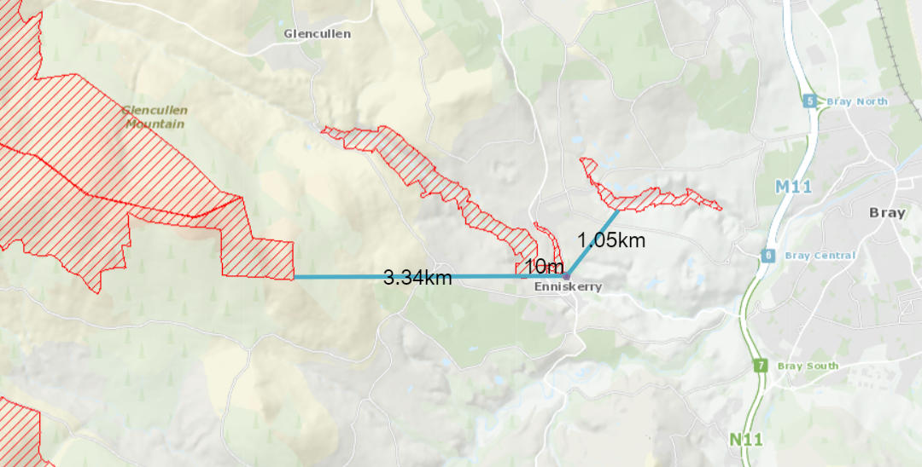
Sites to consider:

Knocksink Wood 000725 0.01km
Ballyman Glen 000713 1.05km
Wicklow Mountains 002122 3.34km
1 | Impacts On Freshwater Habitats  Is the development within a Special Area of Conservation whose qualifying interests include freshwater habitats, or in the catchment of same?  Habitats to consider:  Rivers, Lakes and Lagoons. |  |  | No
2 | Impacts On Wetland Habitats  Is the development within a Special Area of Conservation whose qualifying interests include wetland habitats, or within 1 km of same?  Habitats to consider:  Bogs, Fens, Marshes and Heaths. |  |  | No
3 | Impacts on Intertidal and Marine Habitats  Is the development located within a Special Area of Conservation whose qualifying interests include intertidal and/or marine habitats and species, or within the catchment of same.  Habitats to consider:  Mudflats, Sandflats, Saltmarsh, Estuary; Shingle, Reefs, Sea Cliffs. |  |  | No
4 | Impacts On Woodlands And Grasslands  Is the development within a Special Area of Conservation whose qualifying habitats include woodlands or grasslands habitats, or within 200m of same.  Habitats to consider:  Woodlands, Grasslands or Dunes. |  |  | Yes
Impacts on SPAs
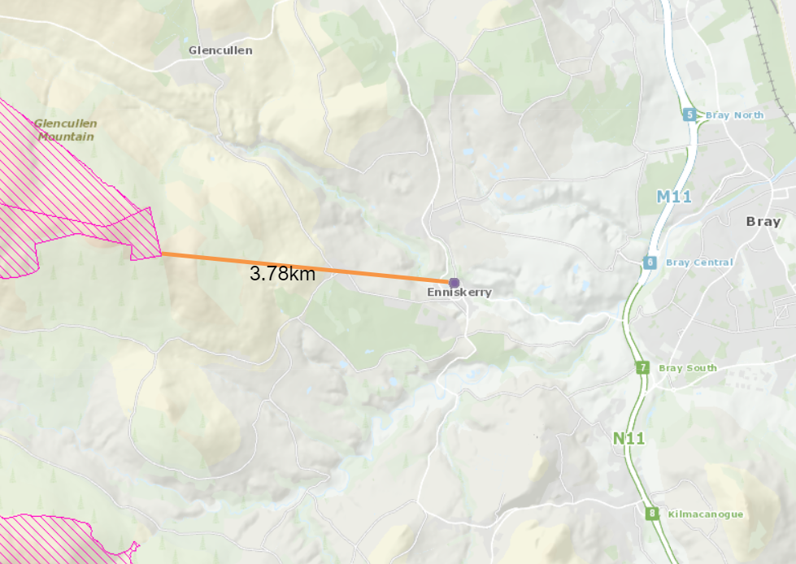
Sites to consider:

Wicklow Mountains 002122 3.34km
5 |  | Impacts On Birds  Is the development within a Special Protection Area, or within 1 km of same. | No

Conclusion Table 2: If the answer to all of these questions is no, significant impacts can be ruled out for Natura 2000 sites. No further assessment is required; proceed to the Habitats Directive Conclusion Statement. Please refer to tables 3 and 4 where the answer to any of these questions is yes.

Table 3: Determination of Possible Impacts On Natura 2000 Sites.
Where it has been identified that there is a Natura 2000 site within the potential impact zone of the proposed development, it is necessary to try to determine the nature of the possible impacts. Please answer the following questions as appropriate.

1 | Impacts on designated freshwater habitats (rivers, lakes streams and lagoons).  Please answer the following if the answer to question 1 in table 2 was yes.  Does the development involve any of the following:
 | Works inside the boundary of designated site
1.1 | All works within the boundary of any SAC whose qualifying features include freshwater habitats/species, excluding small extensions/alterations to existing buildings. |  | N/A
 | Works outside the boundary of designated site
1.2 | Discharge to surface water or groundwater within the boundary of an SAC whose qualifying features include freshwater habitats/species. |  | N/A
1.3 | Abstraction from surface water or groundwater within 1km of the boundary of an SAC whose qualifying features include freshwater habitats or species. |  | N/A
1.4 | Removal of topsoil within 100m of the boundary of an SAC, whose qualifying features include freshwater habitats/species. |  | N/A
1.5 | Infilling or raising of ground levels within 100m the boundary of any SAC whose qualifying features include freshwater habitats/species. |  | N/A
1.6 | Construction of drainage ditches within 1km of the boundary of an SAC whose qualifying features include freshwater habitats/species. |  | N/A
1.7 | Installation of waste water treatment systems; percolation areas; septic tanks within 100 m of the boundary of an SAC site whose qualifying features include freshwater habitats/species. |  | N/A
1.8 | Construction within a floodplain of EU designated watercourse whose qualifying features include freshwater habitats/species. |  | N/A
1.9 | Crossing or culverting of rivers or streams within 1km of the boundary of any SAC whose qualifying features include freshwater habitats. |  | N/A
1.10 | Storage of chemicals hydrocarbons or organic wastes within 100 m of the boundary of an SAC whose qualifying features include freshwater habitats/species. |  | N/A
1.11 | Development of a large scale, within catchment of an EU designated watercourse or waterbody, which involves the production of an EIS. |  | N/A
1.12 | Development or expansion of quarries within catchment of an EU designated watercourse or waterbody. |  | N/A
1.13 | Development or expansion of windfarms within catchment of an EU designated watercourse or waterbody. |  | N/A
1.14 | Development of pumped hydro electric stations within catchment of an EU designated watercourse or waterbody. |  | N/A
2 | Impacts on designated wetland habitats (bog, heath, marsh, fen).  Please answer the following if the answer to question 2 in table 2 was yes.  Does the development involve any of the following:
 | Works inside the boundary of designated site
2.1 | All works within the boundary of an SAC whose qualifying features include heath, marsh, fen or bog, excluding small extensions/alterations to existing buildings. |  | N/A
 | Works outside the boundary of designated site |  | N/A
2.2 | Construction of roads or other infrastructure on peat habitats within 1km of any SAC whose qualifying features include heath, marsh, fen or bog. |  | N/A
2.3 | Development of a large scale within 1km of any SAC, whose qualifying features include heath, marsh, fen or bog, which involves the production of an EIS. |  | N/A

3 | Impacts on designated intertidal and marine habitats (mudflats, sandflats, estuaries, reefs and sea cliffs).  Please answer the following if the answer to question 3 in table 2 was yes.  Does the development involve any of the following:
 | Works inside the boundary of designated site
3.1 | All works within the boundary of any SAC whose qualifying features include intertidal or marine habitats, excluding small extensions/alterations to existing buildings. | N/A
 | Works outside the boundary of designated site | N/A
3.2 | Coastal protection works within 5km of any SAC whose qualifying features include intertidal or marine habitats. | N/A
3.3 | Development of piers, slipways, marinas, pontoons or any other infrastructure within 5km of any SAC whose qualifying features include intertidal or marine habitats. | N/A
3.4 | Dredging within 5km of any SAC whose qualifying features include intertidal or marine habitats. | N/A
3.5 | Works within 1km of any SAC whose qualifying features include intertidal or marine habitats, which will result in discharges to rivers or streams directly connected to the designated site. | N/A
3.6 | Infilling of coastal habitats within 500m of any SAC whose qualifying features include intertidal or marine habitats. | N/A
3.7 | Removal of topsoil or infilling of terrestrial habitats within 100m of any SAC whose qualifying features include intertidal or marine habitats. | N/A
3.8 | Development of a large scale within 1km of any SAC whose qualifying features include intertidal or marine habitats, which involves the production of an EIS. | N/A
4 | Impacts on other designated woodlands and grasslands (woodland, upland grassland, lowland grassland, coastal grassland including dunes).  Please answer the following if the answer to question 4 in table 2 was yes.  Does the development involve any of the following:
 | Works inside the boundary of designated site
4.1 | All works within the boundary of any SAC whose qualifying interests include woodland or grassland habitat types excluding small extensions/alterations to existing buildings. | N/A
 | Works outside the boundary of designated site
4.2 | Development within 200m of any SAC whose qualifying interests include woodland or grassland habitat types. | Yes
4.3 | Development of a large scale within 1km of any SAC, whose qualifying interests include woodland or grassland habitat types, which involves the production of an EIS. | N/A
5 | Impacts on birds in SPAs  Please answer the following if the answer to question 5 in table 2 was yes.  Does the development involve any of the following:
 | Works inside the boundary of designated site
5.1 | All works within the boundary of any SPA excluding small extensions/alterations to existing buildings. | N/A
 | Works outside the boundary of designated site | N/A
5.2 | Erection of wind turbines within 1km of any SPA. | N/A
5.3 | All construction works within 100m of any SPA. | N/A
5.4 | Infilling of coastal habitats within 500m of intertidal SPA. | N/A
5.5 | Works within 1km of coastal/wetland SPAs which will result in discharges to rivers or streams that are directly connected to designated sites. | N/A
5.6 | Development of cycleways or walking routes within 100m of SPAs. | N/A

Conclusion Table 3: If the answer to all of the above is no or n/a, significant impacts on Natura 2000 sites can be ruled out. No further assessment is required; proceed to the Screening Conclusion Statement. If the answer to any question in table 3 is yes, you may require further information, unless you are satisfied that the project proponents have incorporated adequate mitigation into their design to avoid impacts on the Natura 2000 site (eg water pollution protection measures). Such information should be provided in the form of a Natura Impact Statement which should address the particular issues of concern as identified through the above.

Table 4: Consideration Of Potential Impacts On Protected Species
Many of our Special Areas of Conservation are designated for species as well as for habitats. These are listed below, alongside the sites for which they are designated. Included is a short list of the types of activities which could have an impact on these species. Please tick if you are concerned that the proposed development could have an impact on these species.

Species | Relevant Sites | Activites which could have impacts on species | Possible Impacts Identified? Y/N
Otter | Wicklow Mountains  Slaney River Valley | Activities that interfere with river banks. | N
Salmon | Slaney River Valley | Activities that interfere with water quality, levels or the river bed; | N
River Lamprey | Slaney River Valley | Activities that interfere with water quality, levels or the river bed; | N
Brook Lamprey | Slaney River Valley | Activities that interfere with water quality, levels or the river bed; | N
Sea Lamprey | Slaney River Valley | Activities that interfere with water quality or the river bed – estuarine areas; | N
Twaite Shad | Slaney River Valley | Activities that interfere with water quality or the river bed – estuarine areas; | N
Freshwater Pearl Mussel | Slaney River Valley | Activities that interfere with water quality, levels or the river bed ; | N

Conclusion Table 4: If the answer to all of the above is no, significant impacts on species can be ruled out. If the answer to any of the above is yes, then further information is likely to be required in relation to potential for impact on that particular species. Where potential impacts on the above listed species are within designated sites, then further information should be sought in the form of a Natura Impact Statement. Where impacts are outside designated sites, then a species specific survey should be requested.

Habitats Directive Screening Conclusion Statement

Development Type |  | Upgrade of existing car park and provision of a bus turn around and bus terminus
Development Location |  | Bogmeadow Car park, Townland of Monastery, Enniskerry, Co. Wicklow
Natura 2000 sites within impact zone |  | Knocksink Wood SAC
Planning File Ref

Description of the project

Upgrade of existing car park with foot paths, surfacing, kerbs and landscaping to provide 52 parking spaces. Provision of a bus turn around and bus terminus with a bus shelter and a new bus entrance from Monastery Road. Works also include the installation of a public light in the car park and the creation of a raised speed table with a courtesy pedestrian crossing on Monastery Road.

Describe how the project or plan (alone or in combination) could affect Natura 2000 site(s).

The car park site is adjacent to Knocksink Wood, which is a Special Area Conservation, selected for the following habitats [7220] Petrifying Springs*
[91A0] Old Oak Woodlands
[91E0] Alluvial Forests*
The section of Knocksink Wood adjacent to the car park site is characterised by mixed woodland and the habitats for which the wood is protected are located up river and at least 200m from the site. Due to the development location there will be no risk of any discharges to Knocksink Wood. Human activity, particularly noise and lighting at night could impact on the fauna in the adjacent woodland.

If there are potential negative impacts, explain whether you consider if these are likely to be significant, and if not, why not.
Given that the area of land where the works are taking place is currently used as a car park, the impact on Knocksink Wood should be minimal. The current car park area is about 1525 sqm. The paved area will increase by just 140 sqm as a result of the works.
The boundaries of the site will be landscaped with native mixed meadow plants, grasses and trees,
There is the potential for hydrocarbon pollutants from rainwater run-off. Although this will not impact on the SAC, it is proposed using a petrol interceptor to prevent fuel contamination of streams carrying away the run-off.
Lighting fixtures that shield the light source to minimize glare and light trespass will be used to help prevent light pollution that may impact on wildlife in the adjoining wood. Lighting of the car park is required to provide for safety during dark winter evenings. It is not proposed that the car park should facilitate late night activities. Consequently, lighting will be from dusk to midnight only so as not to encourage late night activities that could disturb wildlife.

Conclusion of assessment

The potential negative impacts on a Natura 2000 site are minimal due the location of the site in relation to the protected habitats and any impacts are substantially mitigated due to the limited change in current use, proposed landscaping, installation of a petrol interceptor and the design and operation of lighting,

Documentation reviewed for making of this statement.

NPWS (2020) Conservation objectives for Knocksink Wood SAC [000725] Generic Version

Enniskerry Town Plan 2016-2022
EPA website – www.epa.ie
National Parks and Wildlife website – www.npws.ie

Completed By | Avril Hill BE CEng MICE MIEI, Executive Engineer, Municipal District of Bray
Date | 16/10/20

